**INFOLABZ IT SERVICES PVT. LTD.**

**Course :** React

**Session No :**

**Topics to be covered :** Routing in react

Create a new react project : reactrouting

Install routing package :

Go to project’s terminal > New Terminal

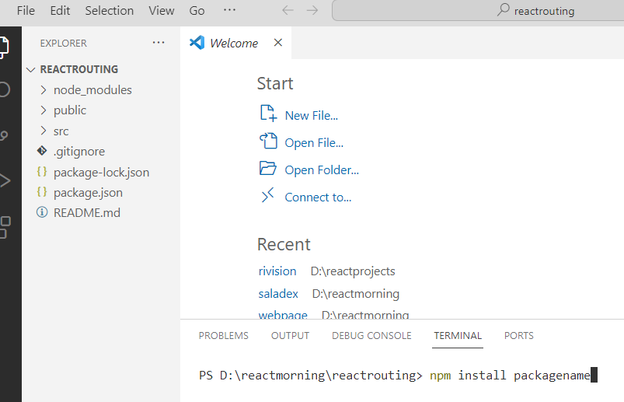

Package Name : react-router-dom

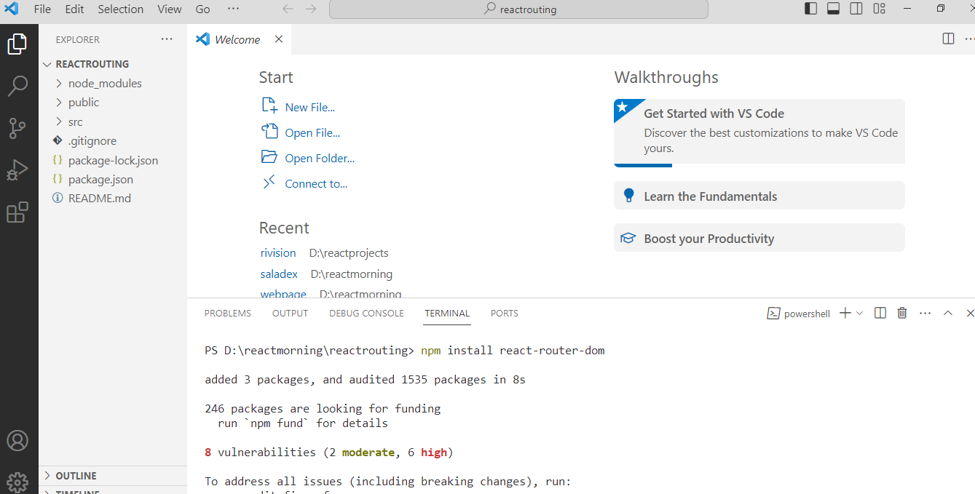

Create a new folder : components

Add sub files for different pages

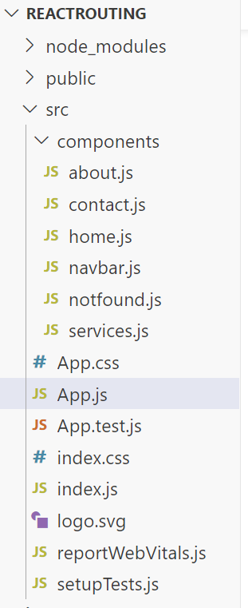

**home.js**

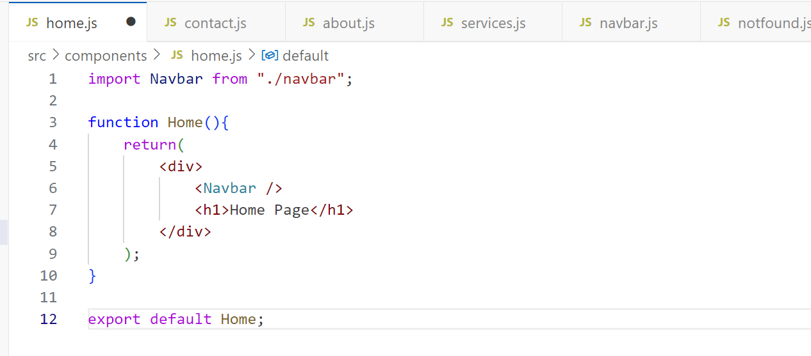

**Services.js**

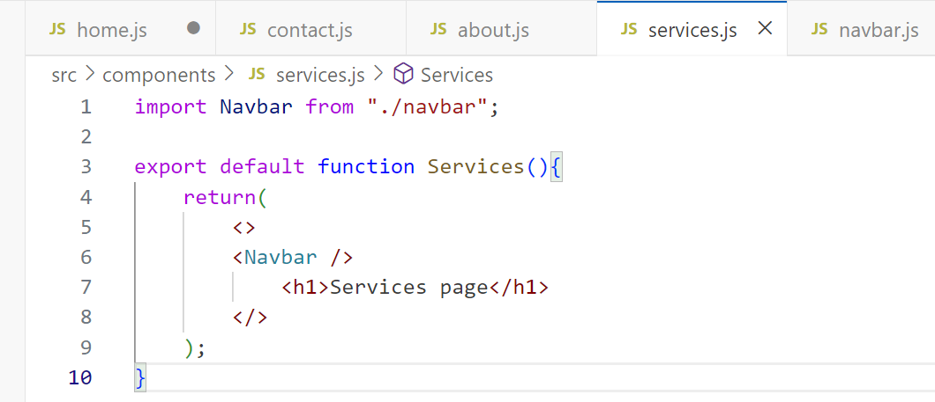

**Contact.js**

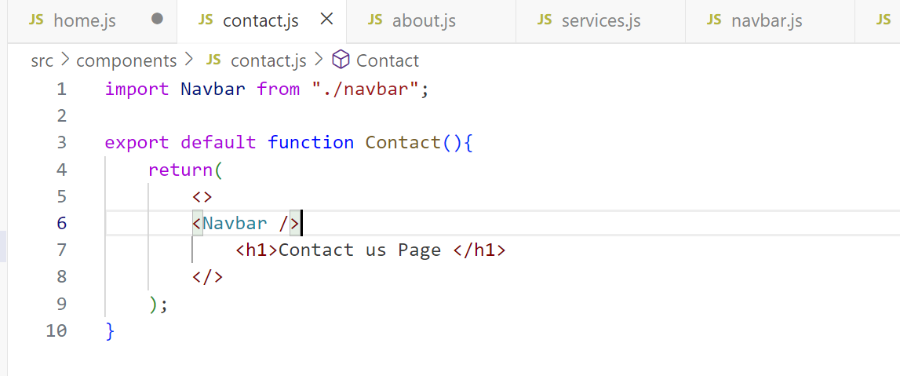

**About.js**

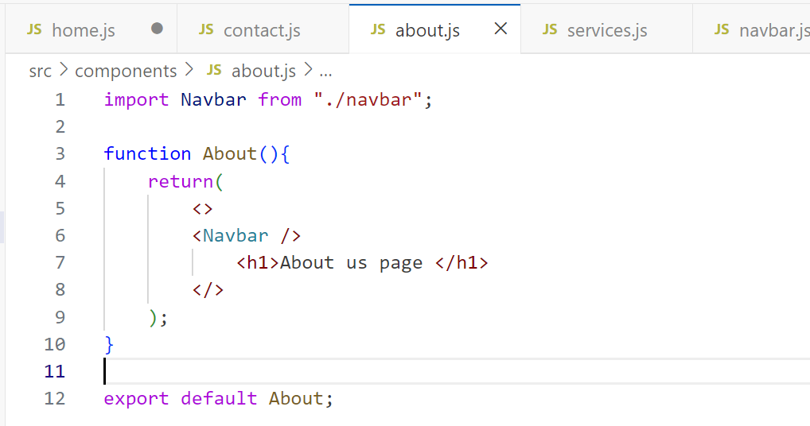

Navbar.js

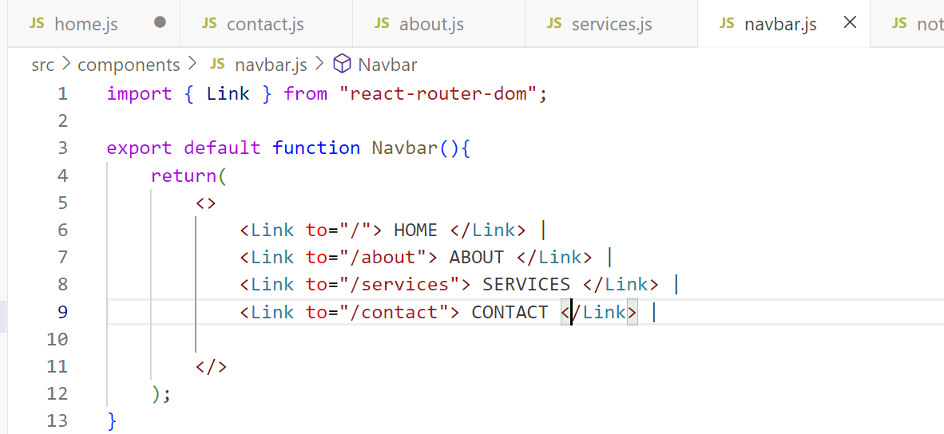

Notfound.js

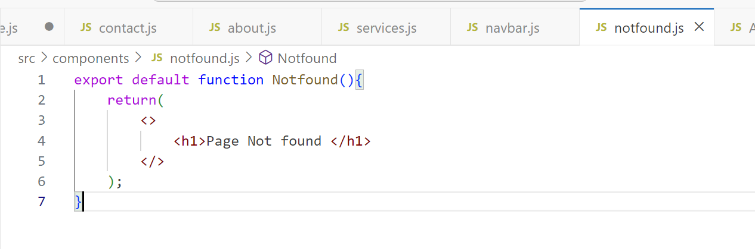

App.js

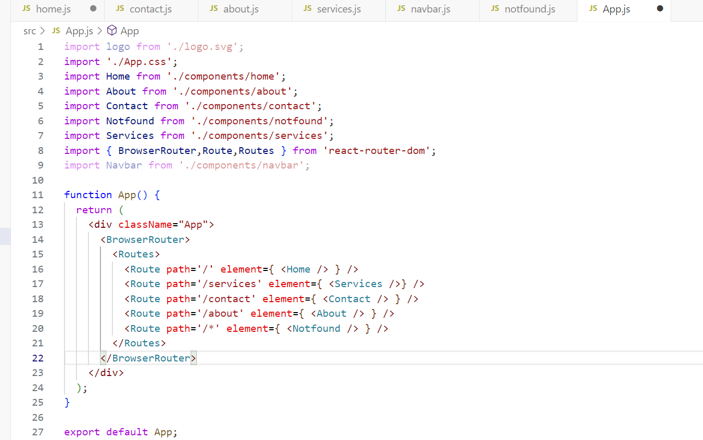

**PRACTICE PROJECT 1 :**

PROJECT NAME: routingpractice

| **PAGES** | **ROUTE TO** |
| --- | --- |
| Home page | About, Events, Courses, Login |
| About college | Home, Events, Courses |
| Events | Home, About, Courses |
| Courses | Home, About, Event |
| Login | Home |

**PRACTICE PROJECT 2 : HTML + CSS + REACT ROUTING**

COMPLETE AS PER PREVIOUS WORK GIVEN : [CLICK HERE TO CHECK WORK](https://docs.google.com/document/d/1eWc7TxtYGPtYMsO3VI0ajFjdlXfAHD8tbxLLlWXXerg/edit?usp=sharing)